Atom type script tools

<https://blog.dripstat.com/best-plugins-for-using-atom-with-typescript/>

9.8.15

# 8 best plugins for using Atom with TypeScript

Atom is the [best editor out there for TypeScript](http://blog.dripstat.com/state-of-typescript-1-6-support/). Here are some plugins to supercharge your webapp development with Atom and TypeScript:

**1.** [**Atom-Typescript**](https://atom.io/packages/atom-typescript)

This is the most up to date and best Typescript plugin out there for any IDE. For more details, check out [our TypeScript editor comparison](http://blog.dripstat.com/state-of-typescript-1-6-support/).

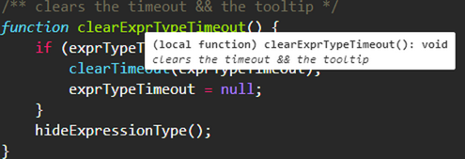

**2.** [**Local Server Express**](https://atom.io/packages/local-server-express)

Creates a local server so you can actually run and test your code in a browser. This is so essential, it really should ship by default with Atom.

**3.** [**Emmet**](https://atom.io/packages/emmet)

Emmet is designed to allow easy editing of html and jsx/tsx files with tons of html specific editor shortcuts.

**4.** [**Gulp control**](https://atom.io/packages/gulp-control)

Allows controlling Gulp. the highly popular Gulp build tool, directly from within Atom.

**5.** [**Pigments**](https://atom.io/packages/pigments)

Any line in a css/scss file containing a color value will be highlighted by that color.

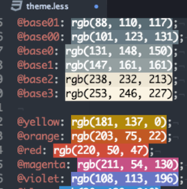

**6.** [**Colorpicker**](https://atom.io/packages/color-picker)

A colorpicker for use in css/scss files.

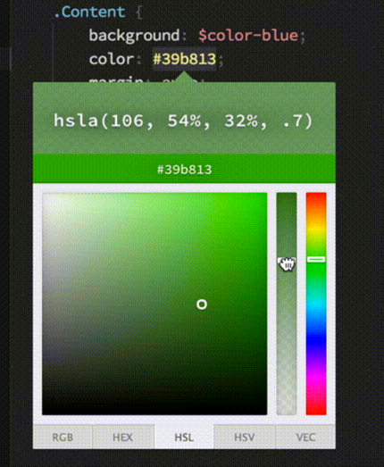

**7.** [**Sass-autocompile**](https://atom.io/packages/sass-autocompile)

When you save your .sass or .scss files, they will automatically be compiled to .css.

**8.** [**Merge conflicts**](https://atom.io/packages/merge-conflicts)

Resolve git merge conflicts directly inside Atom.

